

Inspection and Test Plan – Pavement Base Course (Crushed Rock)

**Project no.**  CC0374 **Project name**  Pakenham Roads Upgrade **Date**  29/11/23 **Approved by**  Damian Hagebols **ITP no.**  1630-P200-SYM-QAC-ITP-0056 **Revision date**  09/01/24 **Plant and equipment used**  **Lot no. Location (chainages, detailed description or marked up plan)**

|  |  |  |  |  |  |  |  |  |  |  |
| --- | --- | --- | --- | --- | --- | --- | --- | --- | --- | --- |
|  | | | | | **Verification of acceptance by** | | | | | **Remarks/record (eg. Test frequency reports, certificates,**  **checklist etc)** |
| **Symal** | | | **Superintendent** | |
| **Item no.** | **Activity** | **Ref docs** | **Acceptance criteria** | **Freq** | **Key** | **Resp** | **Initial/ date** | **Key** | **Sign/ date** |
| **1.0 Pre-start activities** | | | | | | | | | | |
| **1.1** | Check Survey Set-out and TCM’s |  | Record existing TCM’s on TCM offset sheet. Survey set out including frame, benchmark, and recovery points in place. | Prior to start of Works | H | SE |  |  |  |  |
| **1.2** | Crushed Rock Mix Registration | DoT812.04  DoT304.03 | **HP: Crushed rock proposed is a current registered mix in accordance with VR500.02 and conforms to the specified requirements for that class.**  Mix is registered by VicRoads as ‘General’. | Prior to start of works | H | SE |  | **H** |  | Crushed Rock Mix Registration  **Yes □ No □** |
| **1.3** | Addition of Water | DoT304.03 | Water added to the pavement will be clean and suitable for construction and substantially free from detrimental impurities such as oils, salts, acids, alkalis, and vegetable substances, and have no more 1000 mg/L of suspended solids. | Each Lot | I | SE |  |  |  |  |
| **2.0 Installation of Layer** | | | | | | | | | | |
| **2.1** | Maximum allowable lot size for a single layer of work. | DoT304.06(b) T.304.111 | Each lot is a single layer of work, and its size is lesser of 4000m2 or one day’s production. | Each Lot | I | SE |  |  |  |  |
| **2.2** | Delivery Dockets | DoT304.05 | Delivery dockets of the material supplier conform to the requirements outlined in specification VR304.05: Name of supplier, docket number, project name, nature and source of material, and supplier’s stockpile identification number. | Each Lot | I | SE |  |  |  | Delivery Dockets  **Yes □ No □** |
| **2.3** | Conformity with Drawings | DoT304.06 | Pavement course after compaction is smooth and uniform, and free of segregated areas and any water ponding.  **Width**  Width of each side of pavement is not less than specified offset width or more than 50mm outside specified offset width when measured at right angles from centre line or design line. | Each Lot | W | SE |  |  |  |  |

This document is uncontrolled when printed Revision 00 Issue date 09/01/24 Page 1 of 5

|  |  |  |  |  |  |  |  |  |  |  |
| --- | --- | --- | --- | --- | --- | --- | --- | --- | --- | --- |
|  | | | | | **Verification of acceptance by** | | | | | **Remarks/record (eg. Test frequency reports, certificates,**  **checklist etc)** |
| **Symal** | | | **Superintendent** | |
| **Item no.** | **Activity** | **Ref docs** | **Acceptance criteria** | **Freq** | **Key** | **Resp** | **Initial/ date** | **Key** | **Sign/ date** |
|  |  |  | **Surface Level**  Pavement constructed to the lip level of kerb and channel is flush with the lip of the channel or not more than 5mm above.  **Shape**  No point on the layer is >8mm from a 3m straight edge or >10mm from a 6m straight edge. Placed in any direction. |  |  |  |  |  |  |  |
| **2.4** | Conformity with Drawings | DoT304.06 | **W: Any material compacted and then trimmed from the compacted surface to conform to the correct level or thickness as shown on the drawings shall not be re-used in the pavement construction without Superintendent approval.** | Each Lot | R | SE |  | **W** |  |  |
| **2.5** | Construction - Jointing | DoT304.07 | Material has been spread to minimise joints.  Transverse joints are offset from one layer to the next by not less than 2m.  Longitudinal joints are offset from one layer to the next by not less than 150mm and located within 300mm of planned position of traffic lines or within 300mm of centre of traffic lane.  Exposed lot and edge each lot of any part of jointing is kept moist until spreading and compaction is complete over entire layer. | Each Lot | I | SE |  |  |  |  |
| **2.6** | Protection of compacted layer | DoT304.09 | Surface of each compacted layer is in good order/condition & free from contamination until the subsequent pavement work is to commence. | Each Lot | I | SE |  |  |  |  |
| **3.0 Testing** | | | | | | | | | | |
| **3.1** | Testing – Stability (Proof Roll) | DoT304.08(b) DoT173.03(ii) DoT173.03(b) | **HP: The contractor has provided for the Superintendent to attend all test rolling.**  Contact pressure of test vehicle is min. 450kPa/tyre during test over an area of min. 0.035m2/tyre. The layer doesn’t show visible deformation or springing. | Each Lot | H | SE |  | **H** |  | Proof Roll Checklist  **Yes □ No □** |
| **3.2** | Unstable Area Rectification | DoT304.08(b) DoT173.03(b) | Unstable areas identified during the proof roll have been rectified. Prior to any successive layer, the superintendent has required further test rolling to confirm the layer is sound.  Contact pressure of test vehicle is min. 450kPa/tyre during test over an area of min. 0.035m2/tyre. Layer doesn’t show visible deformation or springing. | Each Lot | I | SE |  | **R** |  | Proof Roll Checklist (Post Rectification) **Yes □ No □** |

|  |  |  |  |  |  |  |  |  |  |  |
| --- | --- | --- | --- | --- | --- | --- | --- | --- | --- | --- |
|  | | | | | **Verification of acceptance by** | | | | | **Remarks/record (eg. Test frequency reports, certificates,**  **checklist etc)** |
| **Symal** | | | **Superintendent** | |
| **Item no.** | **Activity** | **Ref docs** | **Acceptance criteria** | **Freq** | **Key** | **Resp** | **Initial/ date** | **Key** | **Sign/ date** |
| **3.3** | Testing – Compaction | DoT304 T.304.081 DoT173.04(d) | Scale A   * Characteristic Density Ratio % (six tests): * **Greater than 100.0% Modified Compaction.** * **Moisture content is at least 85% of optimum until test request is completed.** * **Initial testing frequency:** 1 test per lot. * **Reduced Testing:** Once 3 consecutive lots of like material and/or work is passing, test 1 per 2 lots. If one lot fails, resume 1 test per lot. * **Small Lot:** Lots <500m2 can be CDR 3-Lot and accepted if 3-lot mean value is **at least 102.0%.** Small lots can’t qualify for reduced testing. | Each Lot | R | SE |  | R |  | NATA Test Report: Compaction  **Yes □ No □**  Prev. Tested Lot No. (If reduced frequency)  **…………………………** |
| **3.4** | Post Compaction Grading (Nominal Size = 20mm) | DoT304.10(a) T.304.101 T.304.111 | **Sieve Size | % Passing by Mass**  26.5 mm – **100%**  19.0 mm – **95 - 100%**  13.2 mm – **78 – 92%**  9.5 mm – **63 - 83%**  4.75 mm – **44 - 64%**  2.36 mm – **30 - 49%**  0.425 mm – **14 - 23%**  0.075 mm – **6 - 12%**  **Minimum testing frequency:** 1 test per 2 lots. | Each Lot | R | SE |  | R |  | NATA Test Report: Grading  **Yes □ No □** |
| **3.5** | Post Compaction - Plasticity Index | DoT304.10(b) T.304.111 T.304.103 | PI: 2 – 6 (Class 1)  **Minimum testing frequency:** 1 test per 4 lots. | Each Lot | R | SE |  | R |  | NATA Test Report: Atterberg Limits  **Yes □ No □** |
| **3.6** | Scale A Requirements for Post Compaction Grading and PI Testing | DoT304.11(c)(i) | The first lot of each pavement layer shall be tested for post- compaction grading and PI.  Any reworked lot is re-tested for compliance. | Each Lot | H | SE |  | **R** |  |  |
| **4.0 Completion** | | | | | | | | | | |
| **4.1** | Survey as built | DoT304.06  T. 304.061  T. 304.062 | Surface is smooth, uniform, free of segregation, conforming to grade, thickness, and drawing section. Each measurement is taken at random locations in accordance with the VicRoads Test Method.   * Scale A: 80 measurements per lot are taken. * Mean Range: +5mm to -5mm. * Max Stnd. Deviation: 8mm.   Surface out of tolerance is rectified and re-surveyed. | Each Lot | R | SE |  |  |  | Survey Conformance Certificate  **Yes □ No □** |

|  |  |  |  |  |  |  |  |  |  |  |
| --- | --- | --- | --- | --- | --- | --- | --- | --- | --- | --- |
|  | | | | | **Verification of acceptance by** | | | | | **Remarks/record (eg. Test frequency reports, certificates,**  **checklist etc)** |
| **Symal** | | | **Superintendent** | |
| **Item no.** | **Activity** | **Ref docs** | **Acceptance criteria** | **Freq** | **Key** | **Resp** | **Initial/ date** | **Key** | **Sign/ date** |
| **4.2** | Thickness of Pavement Layers | DoT304.06 (c) DoT304.08(v) | Base course is not less than specified thickness by more than 10mm and average thickness of base over every 100m section over full carriageway width is not less than specified thickness.  Combined thickness of subbase and base courses is not less than specified thickness by more than 15mm.  Maximum base layer thickness is 150mm. | Each Lot | R | SE |  |  |  | Survey Conformance Certificate  **Yes □ No □** |
| **5.0 Work Lot Close Out** | | | | | | | | | | |
| **5.1** | Test Reports | VIC Roads Specifications | All Test reports received and reviewed. | Each Lot | R | SE |  |  |  | NATA Endorsed Tests  **Yes □ No □** |
| **5.2** | Product Non-Conformance | CQMP | All Product Non-Conformance(s) recorded and closed (if applicable) | Each Lot | R | SE |  |  |  | NCR reports  **Yes □ No □** |
| **5.3** | Quality Representative to check the above criteria and records to confirm. | CQMP  Lot Records | All above criteria met, and records identified attached. | Each Lot | R | SE |  |  |  | Completed Checklist (if applicable). reports and other compliance records attached.  **Yes □ No □** |

**Works complete (signer SE) Date works complete**

**Lot conforms (signer PE)**  **Date lot closed**  **NCR/s no. raised**  **Date NCR closed for this lot**

**Responsibility (Resp.) Key**: **PM**-Project Manager, **PE**-Project Engineer, **SE**- Site Engineer, **CS**-Civil Superintendent, **SS**-Site Supervisor, S**V**-Surveyor, **CR**-Client Representative

**SI –** Superintendent

**Inspection Key: W –** Witness, **H –** Hold Point, **S –** Surveillance, **R –** Review Point, **I –** Inspection Point

**Fig 1.**

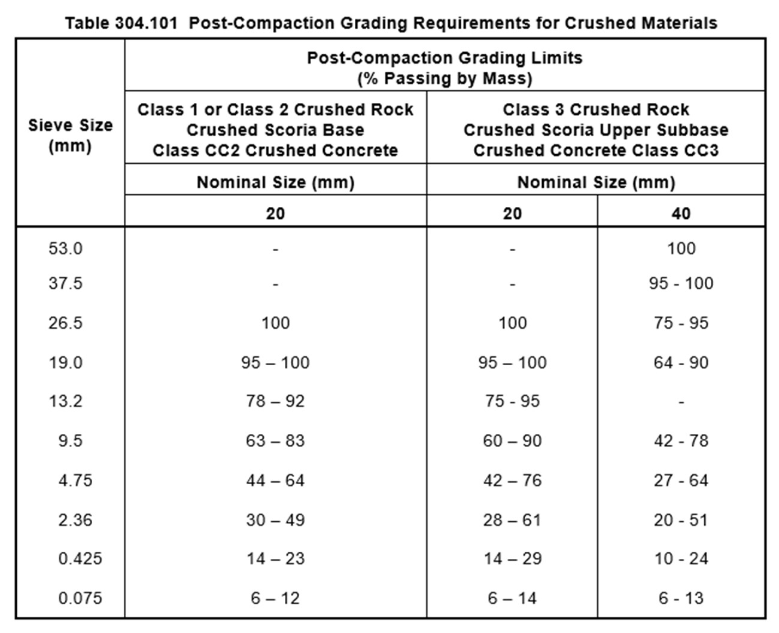

**Fig 2.**

**Fig 3.**

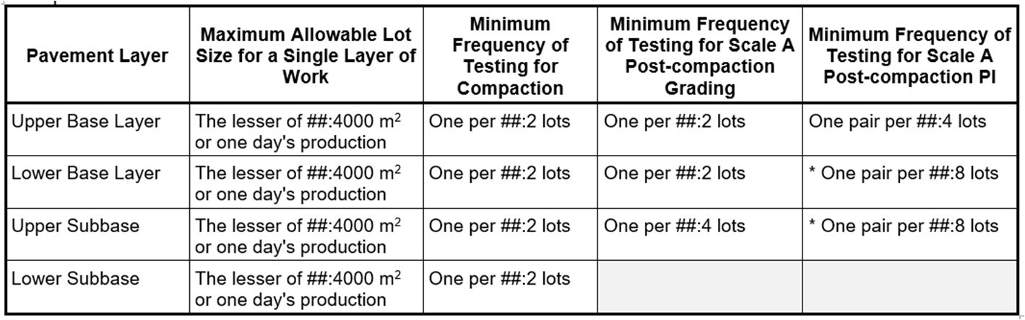

**Fig 4.**

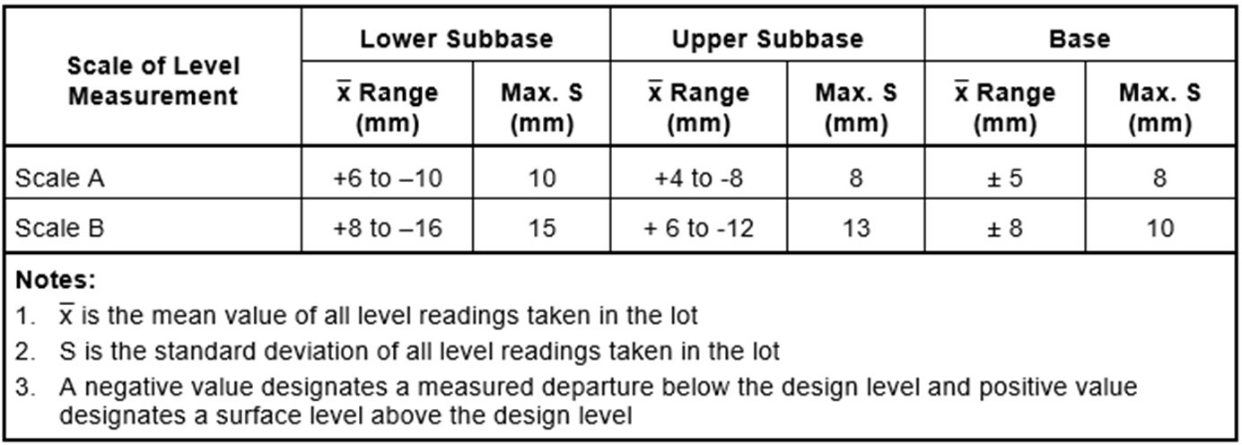

**Fig 5.**

